

**Personal information**



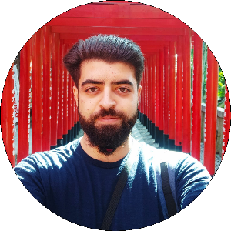

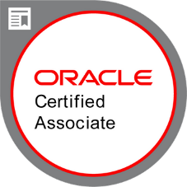







**Studies**

* **Middle degree on IT and networks (Stucom):**
  + Management of Windows and Linux servers
  + Hardware maintenance and repair
  + IT security
  + Office, Photoshop and Adobe premiere
  + DDBB: *MySQL, MongoDB*
* **Superior degree in web application development (Stucom):**
  + Markup languages: *CSS, HTML, XML, XSS, XSD*
  + Programing languages: *PHP, Java, JavaScript, SQL*
  + Frameworks: *Spring, Hibernate, JDBC, JPA, Swing, JQuery, AngularJS*
* **Superior degree in multiplatform application development (Stucom):**
  + Programing languages: *Java, Swift, Kotlin, JavaScript*
  + Frameworks*: Spring, Hibernate, JPA, AngularJS, Cordoba*
  + Environments: *Web, Android, iOS*
  + DDBB: *MySQL, H2, Neo4J*
* **Bootcamp Kotlin base and for Android 15 hours (PUE):**
  + [Title of the course](https://github.com/Corneyeski/certifications-information/blob/master/certifications/IMG_20200622_122223%20(1).jpg)
  + [Details](https://github.com/Corneyeski/certifications-information/blob/master/certifications/kotlin.txt)
* **Bootcamp Swift (iOS) development 40 hours (PUE):**
  + [Title of the course](https://github.com/Corneyeski/certifications-information/blob/master/certifications/IMG_20200622_122152%20(1).jpg)
  + [Details](https://github.com/Corneyeski/certifications-information/blob/master/certifications/Swift.txt)
* **Java SE 8 Oracle certification (PUE):**
  + [Title of the course](https://github.com/Corneyeski/certifications-information/blob/master/certifications/IMG_20200622_122210%20(1).jpg)
  + [Official Oracle certification](https://www.youracclaim.com/badges/558c4f59-d2fe-42ee-9ef7-f2697592732c/linked_i)
  + [Details](https://github.com/Corneyeski/certifications-information/blob/master/certifications/java%208%20cretification.txt)

**Professional experience**

* **2014/2015 - Sonibetica Barcelona - Help Desk**

Technical support to more than 2000 users remotely

* **2015 – Erasmus on Malta**

One month on Malta to improve my English

* **2016/2017 - Ancert - Help Desk**

Monitoring and technical support on Windows servers for all the notaries of all Spain.

* **2017 ICA – Java backend programmer**

I work on *Java projects* with *Spring* and *PHP* projects of *Drupal*, *WordPress* and *Joomla*

* **2017/2018 Opentrends – Java backend programmer**

Working on Java 7/8 projects with Spring using MyBatis, hibernate and JPA with SQL BBDD (Oracle, MySQL)

In addition, I work on a project with AngularJS and Java Spring.

* **2018/2019 Stockcrowd – Fullstack programmer**

SAAS application that offers crowdfunding services developed with Java Spring and hibernate in backend and JSP, jQuery on front-end, I was in charge of the back-office part, developing from the frontend page, to the repository

* **2019/2020 ERNI – professional Backend developer**

The project was for COMLAB, it was a web application that collects information from all the repeaters of the company and tracks the information to show it to the final user in a web page, made it with *Spring, Spring security, Spring REST, JPA, Java 8, Junit testing and H2 database.*

My function was to design and develop the different entities and functionalities for the app and later discuss it with the architect from the client.

We also work with SCRUM methodologies and all communications was in English.

* **2020/2020 (7 months) Crealogix – professional Backend developer**

Company that offers IT solutions for banks, currently working on a micro-services application, with Java 8, Spring.

* **2020/currently Hexad – professional Backend/Full stack developer**

Company that offers IT solutions for banks, currently working on a micro-services application, with Java 8, Spring.

**Languages**

* **Native language:** Spanish, Catalan.
* **English:** high level.

**Languages and Frameworks**















**Tools:** JHipster, GIT, SVN, Redmine, NPM, Maven, Grandle, Neo4J, JIRA, Oracle web service, Postman, Swagger, Linux, Windows